SOFTWARE ENGINEERING LAB

LAB CODE
3CS4-23
Submitted By
[Sonu Kumar Gupta]
[24EARCS165]

Under the supervision of
Dr.Krishan Kant Lavania
Professor



Session 2025-26

Department of Computer Science & Engineering

ARYA COLLEGE OF ENGINEERING & I.T.
SP-42, RIICO INDUSTRIAL AREA, KUKAS, RAJASTHAN

Experiment – 01 Introduction to SDLC models

Date of Performance : | Date of Evaluation :

Project Goal:

The main goal of the – is to create a realistic and intelligent traffic control simulator that can analyze and manage traffic lights using sensor inputs and time-based control.
This system helps to:

- Understand and improve traffic flow efficiency.
- Reduce vehicle waiting time and congestion.
- Provide real-time statistics such as vehicle count, average speed, and system efficiency.
- Allow users to simulate, analyze, and optimize traffic signal timings in a virtual environment.
It serves as a learning tool for traffic engineers and students to study how smart traffic systems work.

Stakeholder Interview & Questionnaire

Stakeholders:

- Traffic Management Authority – They need simulation tools for planning and testing traffic control strategies.
- Developers / Engineers – They build, test, and optimize the system.
- Students / Researchers – They use it for learning and traffic modeling studies.
- System Administrator – Maintains database and server performance.

Experiment – 1B Stakeholder Interview, Questionnaire

Date of Performance : | Date of Evaluation :

Stakeholder Interview Questions (Simple):
- What are the major traffic problems you face daily?

- How do you currently manage signal timing at intersections

- Would you like to test different signal durations using a simulator?

- How important is vehicle waiting time for you to monitor?

- Do you want live data analytics like vehicle speed or queue length?

- What kind of interface would you prefer — simple buttons or advanced dashboards?

- Should the system automatically adjust light timing based on traffic density?

- How frequently should reports be generated?

- Would you like the system to simulate multiple intersections?

- What are your expectations from this simulation system?

Experiment – 02 Software Requirement Specification
Date of Performance : | Date of Evaluation :

SOFTWARE REQUIREMENTS SPECIFICATION (SRS)
Project Title: Advanced Traffic Simulation System
Department: Computer Science & Engineering
University / College: Arya College of Engineering & IT
Date:

1. INTRODUCTION

1.1 Purpose
The purpose of this Software Requirements Specification (SRS) document is to define and describe all the functional and non-functional requirements of the Advanced Traffic Simulation System (ATSS).
This SRS provides a complete description of the system’s behavior, constraints, interfaces, and required performance.
It is intended for:
- System developers
- Project managers
- Test engineers
- Students/researchers
- Any stakeholder involved in traffic management simulation
The document ensures everyone has a shared understanding of what the system must do.

1.2 Scope
The ATSS is a simulation-based software designed to:
- Model real-world urban traffic
- Process data from sensors
- Automatically adjust signal timings
- Predict vehicle movement
- Reduce congestion through intelligent algorithms
The system simulates:
- Traffic flow on multiple roads
- Vehicle density and waiting time
- Dynamic signal timing
- Emergency priority (e.g., ambulance)
The software aims to:
- Improve road efficiency
- Provide visual simulation
- Analyze and generate system reports
This project does not control real hardware signals in real life; it provides a simulated environment.

1.3 Definitions, Acronyms, Abbreviations
Term | Meaning
ATSS | Advanced Traffic Simulation System
GUI | Graphical User Interface
API | Application Programming Interface
DB | Database
LED | Light Emitting Diode (traffic lights)
Simulation Engine | Core program that runs the traffic model
Frame | One cycle of simulation update
Density | Amount of vehicles per road segment

1.4 References
- IEEE 830 – Software Requirements Specification Standard
- IEEE 29148 – Systems and Software Engineering
- Traffic Flow Theory Manual
- Urban Traffic Management Guidelines

1.5 Overview
This SRS includes:
- System description
- Functional requirements
- Performance requirements
- System models (DFD, UML, decision table)
- Constraints and assumptions

2. OVERALL DESCRIPTION

2.1 Product Perspective
The ATSS is a stand-alone software system consisting of:

Subsystems:
- User Management Module
- Sensor Data Processing Module
- Traffic Signal Control Module
- Simulation Engine
- Reporting & Dashboard Module
The system communicates internally using:
- Local database
- Internal APIs
- Data structures representing vehicles, roads, and signals
External systems required:
- None (simulation-only environment)

2.2 Product Functions (High-Level)
The system provides the following major functions:

1. User Management
- Login
- Authentication
- Session management

2. Sensor Data Handling
- Collect sensor data (simulated values)
- Clean/filter data
- Store in database

3. Traffic Control
- Calculate traffic density
- Decide green/red timing
- Update traffic signal state
- Handle emergency vehicles

4. Simulation Engine
- Render traffic animation
- Update vehicle positions
- Predict flow using algorithms

5. Reports & Analytics
- Generate congestion report
- Average waiting time
- Peak hour detection
- Export results

2.3 User Characteristics
User Type | Skills | Role
Administrator | Technical knowledge | Configure system
Traffic Officer | Basic computer knowledge | Monitor traffic patterns
Student/Researcher | Moderate | Analyze and experiment
Developer | Advanced | Extend or modify system

2.4 Constraints
- Real-time performance required
- Limited computational resources
- Processing speed depends on number of vehicles
- Must run on Windows/Linux
- Uses simulations, not real sensors

2.5 Assumptions & Dependencies
- Vehicles behave according to predefined rules
- Sensor values provided as input are assumed correct
- Stable power supply and system resources
- User understands basic traffic management concepts

3. SPECIFIC REQUIREMENTS

3.1 Functional Requirements

3.1.1 User Login Module
FR-1: The system shall allow the user to log in using username and password.
FR-2: The system shall validate credentials using the database.
FR-3: The system shall deny access for invalid users.
FR-4: The system shall log out the user on request.

3.1.2 Sensor Data Input Module
FR-5: The system shall accept simulated sensor data from input module.
FR-6: The system shall clean, filter, and validate the sensor data.
FR-7: The system shall compute the number of vehicles per lane.

3.1.3 Traffic Density Calculation
FR-8: The system shall calculate traffic density for each lane.
FR-9: The system shall compute congestion level (High/Medium/Low).

3.1.4 Signal Timing Decision Logic
FR-10: The system shall generate dynamic signal timing.
FR-11: Green light duration must match traffic density.
FR-12: Emergency vehicles shall be given priority.

3.1.5 Simulation Engine
FR-13: The system shall animate vehicle movement.
FR-14: The engine shall update movement at every frame.
FR-15: The system shall simulate traffic signals (red/yellow/green).

3.1.6 Reports & Analytics
FR-16: The system shall generate traffic history reports.
FR-17: The system shall show average waiting time.
FR-18: The system shall display congestion heat map.

3.2 External Interface Requirements

3.2.1 User Interface (UI)
- Clear GUI with dashboard
- Real-time signal animations
- Graphs for density and timings

3.2.2 Hardware Interface
- Keyboard/Mouse
- Display Monitor
(Real sensors are simulated)

3.2.3 Software Interface
- SQLite/MySQL database
- Internal APIs for modules

3.3 Performance Requirements
- System must process each frame within 50 ms
- Sensor data processing delay < 1 second
- Simulation must support minimum 500 vehicles smoothly
- Signal update must respond within real-time constraints

3.4 Safety Requirements
- System must not crash on invalid input
- Data must be backed up automatically
- Prevent data loss during unexpected shutdown

3.5 Security Requirements
- Passwords must be encrypted
- Unauthorized users cannot access simulation
- Admin-only access for configuration changes

3.6 Software Quality Attributes
- Reliability: Must run without crashing
- Usability: Simple and easy, friendly UI
- Efficiency: Lightweight and fast simulation
- Maintainability: Modular code structure
- Portability: Should run on multiple OS

4. APPENDICES

4.1 UML Diagrams
- Sequence Diagram
- Activity Diagram
- State Diagram

4.2 DFD Models
- Level 0 DFD
- Level 1 DFD
- Level 2 DFD

Experiment – 2B Feasibility Study – Technical, Economic
Date of Performance : | Date of Evaluation :

- Feasibility Study
Type | Description
Technical Feasibility | Can be implemented using HTML, CSS, JS for frontend; Python/Node.js for backend; and SQL database. All tools are freely available.
Economic Feasibility | Cost-effective — only development time is needed; no hardware cost.
Legal Feasibility | No violation of legal or traffic regulations since it’s a simulator.
Operational Feasibility | Easy to operate through browser; minimal training needed.
Schedule Feasibility | Can be completed within 6–8 weeks including design, testing, and documentation.

Feasibility Report
The system is feasible in all aspects — technically, economically, legally, and operationally.
It provides a reliable, efficient, and educational simulation for real-world traffic scenarios.

High Level Design

1. System Architecture
The Advanced Traffic Simulation System is made of three main parts:
1️. Frontend (User Side)
2️. Backend (Logic Side)
3️. Database (Storage Side)

Experiment – 2C High Level Design (HLD)
Date of Performance : | Date of Evaluation :

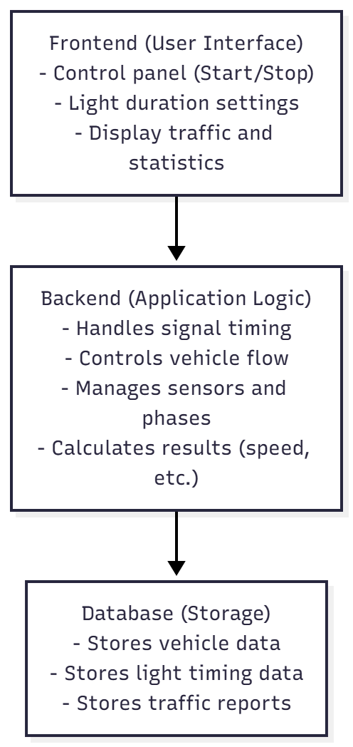

2. Technology Used
Part | Technology | Use
Frontend | HTML, CSS, JavaScript | To make the design and control panel.
Backend | Node.js | To run the logic and control signals.
Database | MongoDB | To save all data and results.
Tools | VS Code, GitHub | For development and version control.
Libraries | Canvas | To show live graphs and animations.

Experiment – 3 Data Flow Diagram (Level-0, Level-1) creation
Date of Performance : | Date of Evaluation :

Data Flow Diagrams (DFD)

Level 0 DFD :
The whole system is shown as ONE single process.

Process:
0. Advanced Traffic Simulation System

External Entities:
- User (Admin / Operator)
- Traffic Sensors
- Traffic Light Controller

Data Flow:
- User → Login Request, Commands
- System → Output, Reports, Updated Signals
- Sensors → Vehicle Count, Traffic Density
- System → Processed Data, Control Signals
- Traffic Lights → Status

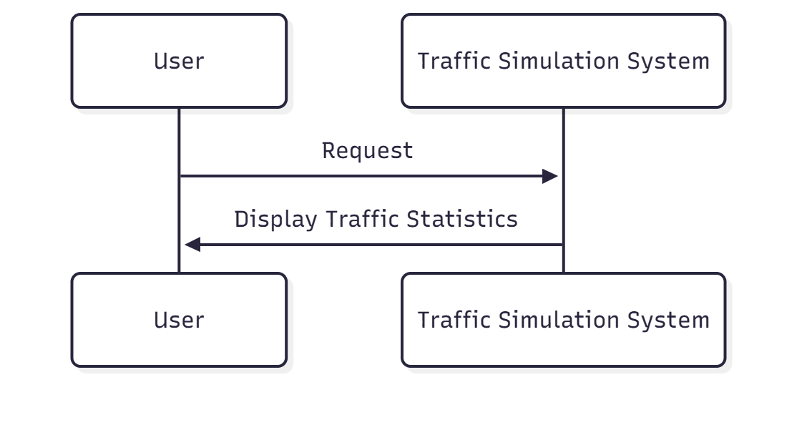

Level DFD 1 :
Break Level-0 into main subsystems.

Processes:
- 1.0 User Management
  - Login
  - Access control
- 2.0 Sensor Data Processing
  - Collect sensor data
  - Filter & store
- 3.0 Traffic Control Module
  - Control traffic lights
  - Update timer & signal state
- 4.0 Simulation Engine
  - Run simulation
  - Generate logs & reports

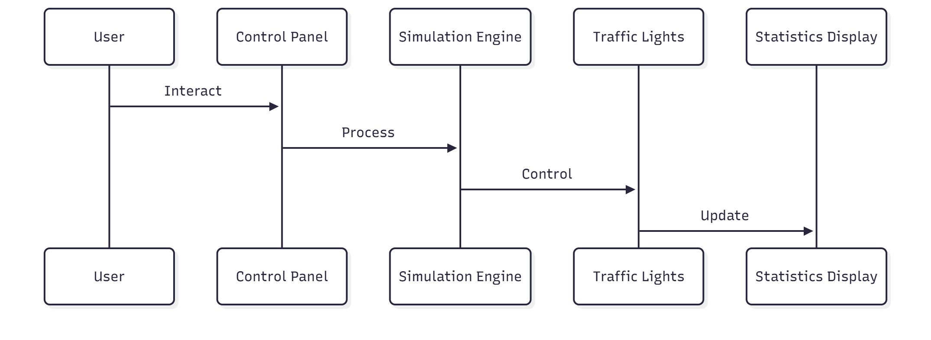

Level 2 DFD:
Now break each Level-1 process into detailed steps.

1. User Management
- Login input → Verify → Give access
(Uses User DB)

2. Sensor Data Processing
- Collect data → Filter → Calculate density → Store
(Uses Sensor DB)

3. Traffic Control Module
- Read density → Calculate timing → Update signal → Send to controller
(Uses Traffic Light DB)

4. Simulation Engine
- Run simulation → Generate logs → Store
(Uses Simulation Log DB)

Experiment – 4 Data Dictionary & Structured Design (Structure Charts)
Date of Performance : | Date of Evaluation :

1. Table: USERS :

Field Name | Description | Data Type | Size | Example
User_ID | Unique ID of user | Integer | 10 | 101
Username | Login username | Varchar | 30 | rohit123
Password | Encrypted login password | Varchar | 100 | ****
Role | Type of user (Admin/Operator) | Varchar | 10 | Admin
Last_Login | Last login date/time | DateTime | — | 2025-01-05 10:30

2. Table: TRAFFIC_LIGHTS :

Field Name | Description | Data Type | Size | Example
Light_ID | Unique traffic light ID | Integer | 10 | 201
Location | Area or junction name | Varchar | 50 | MG Road Junction
Current_State | Current signal (Red/Yellow/Green) | Varchar | 10 | Green
Timer_Value | Remaining time for the active signal | Integer | 3 | 25

3. Table: INTERSECTIONS :

Field Name | Description | Data Type | Size | Example
Intersection_ID | Unique ID of intersection | Integer | 10 | 301
Name | Name of intersection | Varchar | 50 | Main Circle
No_Of_Roads | Number of connected roads | Integer | 2 | 4
Traffic_Load | Current traffic density value | Integer | 5 | 62

4. Table: VEHICLES :

Field Name | Description | Data Type | Size | Example
Vehicle_ID | Unique vehicle ID | Integer | 10 | 501
Vehicle_Type | Car/Bike/Bus/Truck | Varchar | 20 | Car
Speed | Current speed in km/h | Integer | 3 | 45
Position | Current location in simulation map | Varchar | 50 | Sector 12 Lane 3

5. Table: SENSOR_DATA :

Field Name | Description | Data Type | Size | Example
Sensor_ID | Unique sensor ID | Integer | 10 | 901
Location | Sensor location | Varchar | 50 | Junction 5
Vehicle_Count | Number of vehicles detected | Integer | 5 | 48
Time_Recorded | Time of data capture | DateTime | — | 2025-01-05 10:40

STRUCTURED DIAGRAM (Structure Chart) :
A Structured Diagram shows the top-down design of the system.
It breaks the main system into modules such as User Management, Sensor Processing, Traffic Control, and Simulation Engine.
Each module is further divided into small functions like login check, data filtering, timing calculation, and log generation.

Experiment – 5 Structural UML Diagrams: Class, Object, Component Diagrams
Date of Performance : | Date of Evaluation :

1. Class Diagram :

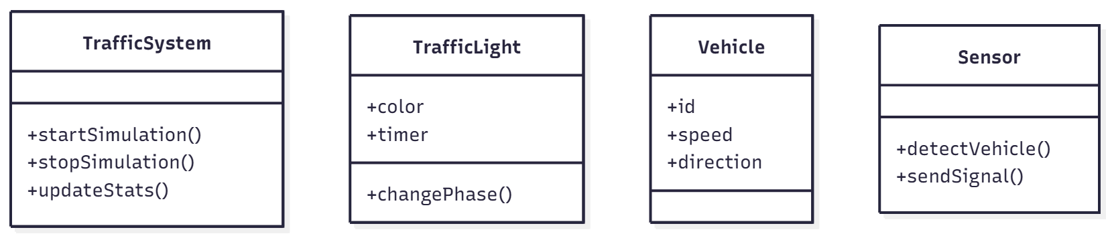

2. ER Diagram :

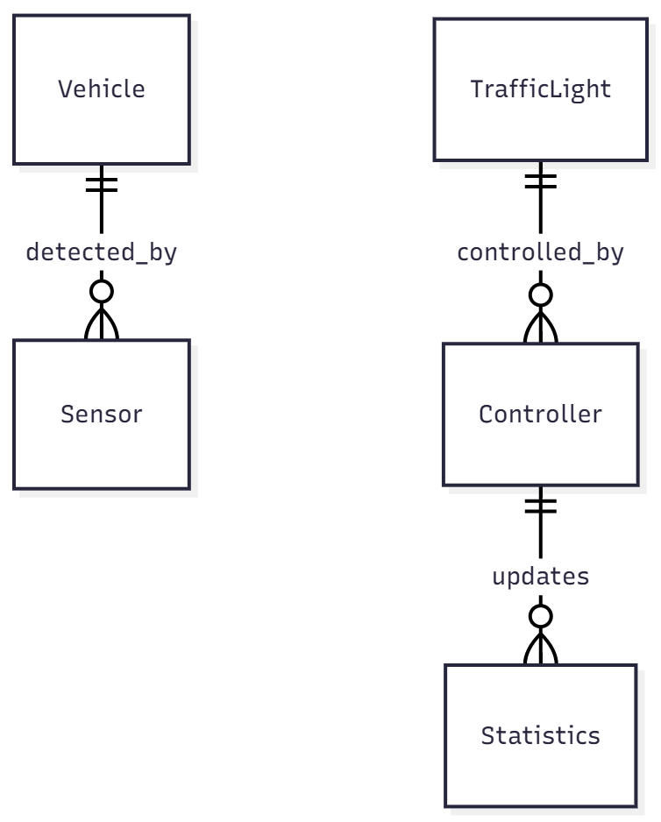

Experiment – 6 Behavioral UML Diagrams: Use Case, Sequence, Activity, State Diagrams
Date of Performance : | Date of Evaluation :

USE CASE DIAGRAM (Behavioral UML)
Actors:
- Admin
- Operator
- Traffic Sensor
- Traffic Light Controller
+-----------------------------+
| Advanced Traffic Simulation |
+-----------------------------+

Admin ------------------> (Manage Users)
Admin ------------------> (View Reports)

Operator -------------> (Login)
Operator -------------> (Control Traffic Lights)
Operator -------------> (View Simulation Output)

Traffic Sensor -------> (Send Traffic Data)

Traffic Light
Controller <------ (Receive Light Commands)

3. State Diagram :

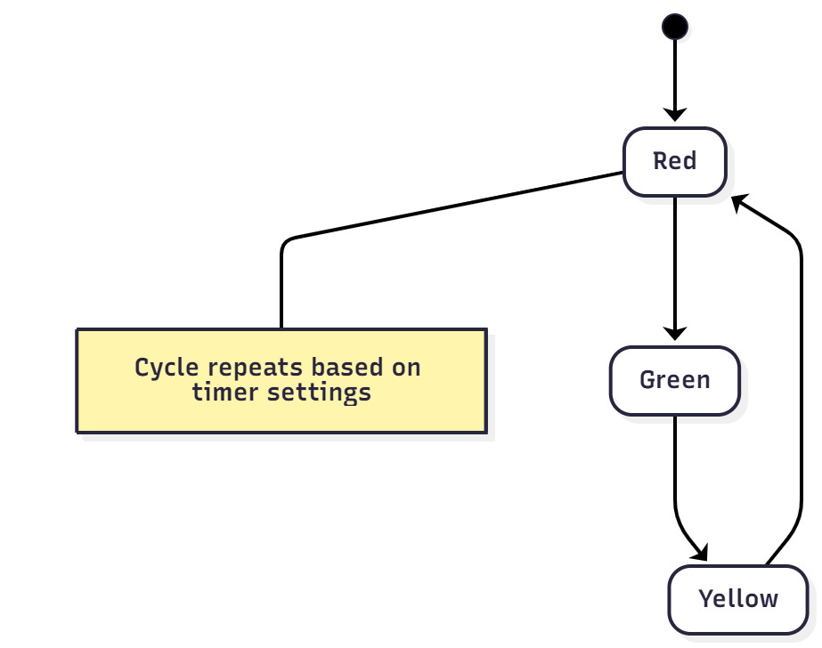
Sequence Diagram
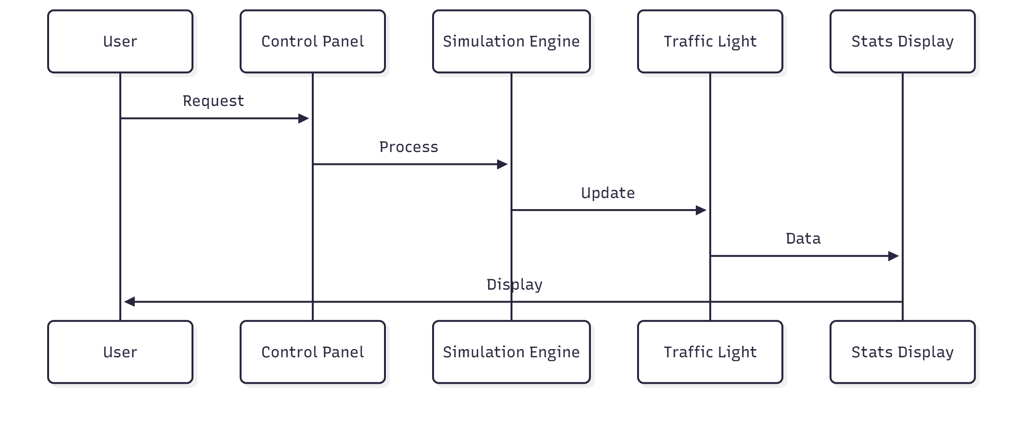

7. Database Schema Design
Table Name | Fields | Description
vehicles | id, direction, speed, spawn_time | Stores each vehicle’s data
lights | id, direction, color, duration | Stores signal info
stats | id, total_vehicles, avg_speed, efficiency | Stores simulation summary

Database Schema Design
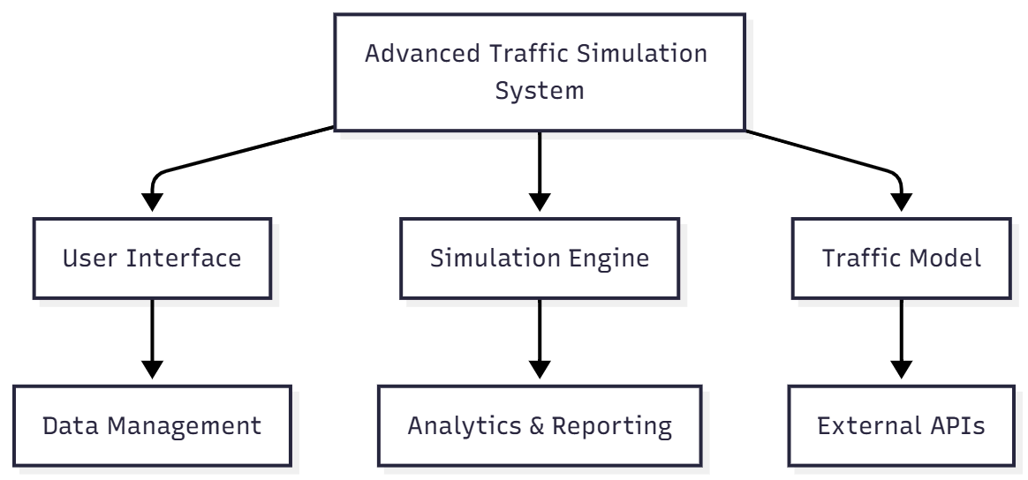
Activity Diagram

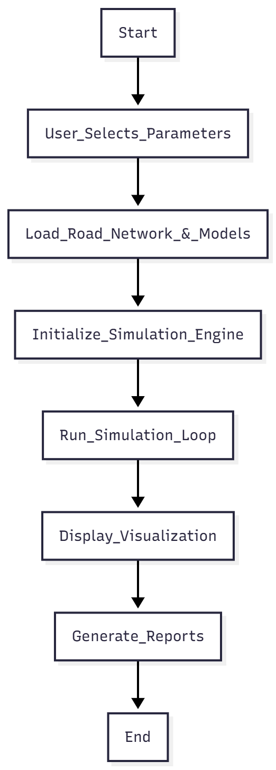

State Transition Diagram :
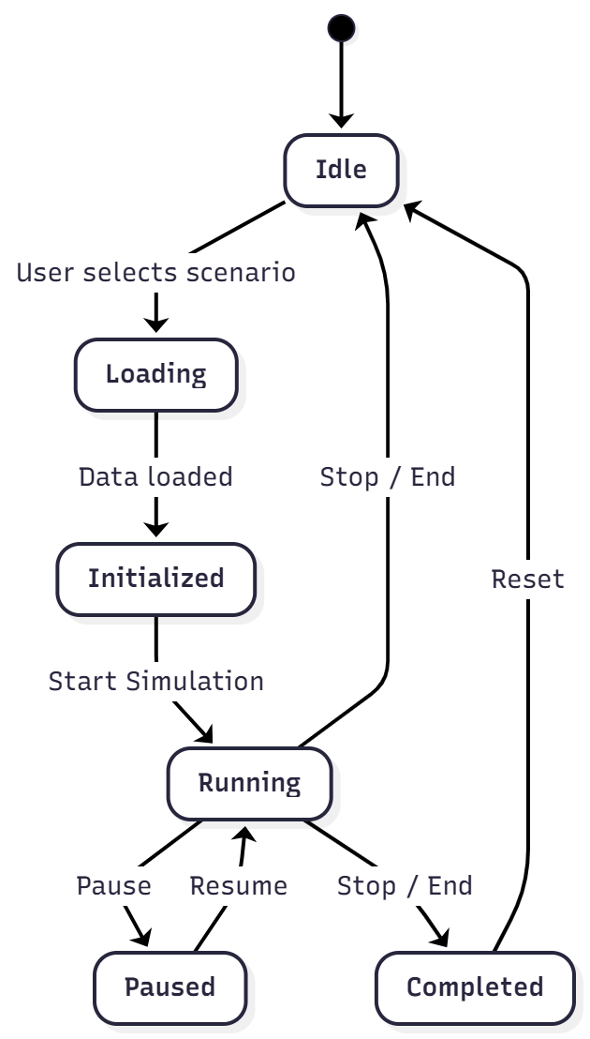

Decision Table – Simulation Control
Current State | User Action | Next State | System Action
Idle | Load Scenario | Initialized | Load data and models
Initialized | Start Simulation | Running | Begin simulation
Running | Pause | Paused | Stop updates temporarily
Running | Stop | Completed | End simulation and show report
Paused | Resume | Running | Continue simulation
Completed | Reset | Idle | Clear data and reset system

DECISION TABLE :-

Condition Variables
- C1: High Traffic Density
- C2: Medium Traffic Density
- C3: Low Traffic Density

Action Variables
- A1: Long Green Time
- A2: Normal Green Time
- A3: Short Green Time
- A4: Red Signal
Condition / Action | Rule 1 | Rule 2 | Rule 3
C1: High Density | T | F | F
C2: Medium Density | F | T | F
C3: Low Density | F | F | T
A1: Long Green | ✔ | — | —
A2: Normal Green | — | ✔ | —
A3: Short Green | — | — | ✔
A4: Red | — | — | —

